Starter Packs July 2017
The Scheme has been helping people when they move from homelessness to a new home. Usually, they will move into an empty flat and will have few possessions. The Starter Pack Scheme provides them with the essential items they need with the exception of furniture. Most of the items are recycled from donations of second hand goods. However, kettles, pillows and duvets are purchased new, as are items in a utility pack which contains washing-up liquid, deodorants, soap etc.
In 2015, it became apparent that there had been a sharp increase in demand. The reason for this is likely due to Bromley Council limiting welfare grants. The bar chart below shows how this increase has developed. To improve both efficiency and record-keeping, all applications for starter packs now use an online system. This ensures that the figures obtained over the last 3 years are accurate. The increase in demand has naturally led to an increase in expenditure.

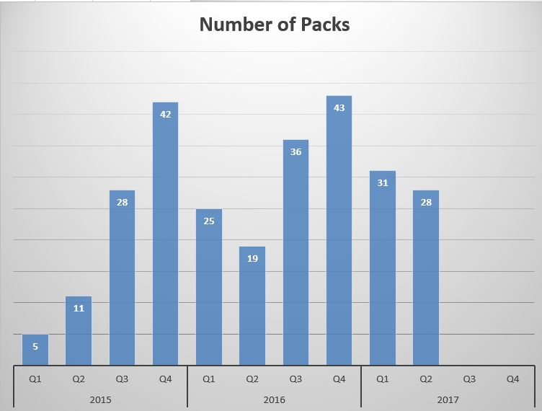

The following chart shows the number of people benefitting from the Starter Pack Project.

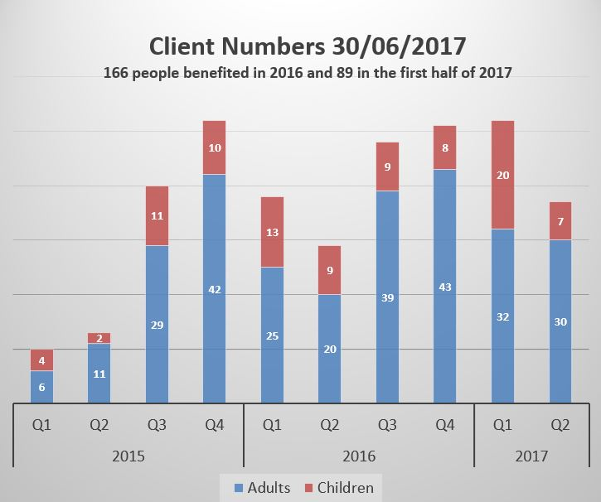

The Rotary Clubs of Bromley, Waitrose and a number of individuals have made donations. Both Thackray Williams (2016) and Judge Priestly (2017), solicitors, have provided goods and volunteer support. The LATCH project provided substantial assistance to the Starter Pack Scheme in 2016 by purchasing many items. A generous donation by an anonymous individual in 2016, together with some fundraising has meant that the project is not currently in deficit. In 2017, the Bromley Community Fund donated £1500. Currently Bromley Parish Church is collecting money for the project.
The value of each pack for a single person, if purchased at a discount store, is approximately £102. However, if sufficient donated goods are available, this reduces to £45. It is anticipated that more than 100 packs will be donated to clients in 2017, with 59 in the first half of the year already. The cost for the year will be between £5000 and £8000.
The majority of applications for Starter Packs are made by Bromley Council Support and Resettlement Service. However, a significant number of referrals is from other agencies such as Woman’s Aid and Hestia, which is a support service for housing association tenants. Preference is given to local residents, though recently Crisis in Croydon has also received some packs. The latter exception is due to the increased cooperation with The Bromley Homeless Shelter.

65% of the clients were male versus 35% female.
Details of the clients for 2016 and the first half of 2017 are shown in the figures below.

These figures are given as a percentage and do not add up to 100% as some clients have more than one issue. The distribution of the issues is almost identical for 2016 and the first half of 2017.
Conclusions drawn from these are that mental health at 47% is a major issue amongst the homeless, with alcohol and drug abuse at 37% being second.

In terms of ethnicity, Bromley is 77% white and 10% black with 3.8% Asian. Thus, relative to the population distribution, white people are somewhat less likely to be re-housed, black are twice as likely and Asians are very unlikely to need to be re-housed. The proportion of white people rehoused was slightly less in the first half of 2017. To be re-housed people need to be homeless first, so this may also be a rough measure of ethnic distribution of homelessness.

In the first half of 2017, relatively fewer males aged between 26 and 35 have received starter packs compared with 2016.

In the first half of 2017 here has been a huge increase in the number of females aged between 16 and 25 compared to 2016.

